Design Document for a Knowledge Transfer ‘area’ of CMMAP website 6/20/2007

Why: There is a need to ‘openly’ communicate CMMAP KT activities to the Center’s stakeholders. A KT web area will enhance ‘horizontal’ or ‘two way’ communication between the Center and its partners, and ‘vertical’ communication to the public. This document reviews the KT goals and objectives related to a KT web area and outlines a ‘Strawman’ web design to help accomplish these and objectives.

KT strategic goals and objectives related to the KT area of the CMMAP website:

Goal A. Enable improved climate models
Goal B. Enable improved weather forecasts
Goal F. Create an appropriate venue for the dissemination of CMMAP results to both the scientific community and the general public.

Objective 1. Provide to climate modeling centers improved tools for the simulation of global cloudiness, as well as innovative tools for the analysis of such simulations. Relates to Goal A.

Objective 2. Provide improved cloud parameterizations to numerical weather prediction centers. Relates to Goal B.

Objective 5. Create and maintain a website containing a section designed to make CMMAP results easily available to the scientific community, and a section designed to increase public understanding of issues in global climate modeling. Relates to Goals E and F. (note, Goal E pertains to the Journal project which is covered under KT Objective 4.)

How: Create a KT area of the CMMAP website that enhances communication between the Center, its partner organizations, and the public. This web area will have approximately six main sections. A brief overview, followed by an outline of each section, follows.

Overview of the Sections:

Section 1. The KT ‘Home’ page introduces the role of KT in CMMAP. The page hosts a bulletin board listing past and future KT meetings and events. Sub-sections for the general public and policy makers provide information about CMMAP and help site visitors navigate the CMMAP website. A “links” section provides links to pages with CMMAP results, data from partner Centers, and other data resources. This section relates to Objective 5.

Section 2. This Section hosts short papers on CMMAP research topics written at a level to inform the general public. These papers follow the model of short papers on the GFDL website. This Section relates to Objective 5.

Section 3. The ‘Student’ Section has information about resources available to students and post docs at CMMAP and its partner Climate and NWP Centers. Student and post doc involvement is seen as a way to transfer products of CMMAP research to the partner organizations and therefore relates to Objectives 1 and 2. There may be overlap with CMMAP ED activities, in which case the ED Committee will participate in development.

Section 4. ‘Publication Projects’ introduces the CMMAP book and journal projects. This section simply informs users about the book and journal projects and does not attempt to meet the strategic objectives set forth for these projects.

Section 5. “KT Partnerships” documents the Center’s activities with partner organizations. Activity entries describe specific projects, list the individuals involved, and outline proposed outcomes. This section relates to Objectives 1 and 2. There may be overlap with the Student Section where KT partnerships involve students.

Section 6. Interactive Tools. These could be a link to the CMMAP report page, a bookkeeping tool (KT record), or fun and/or interesting tools (such as a dynamic map showing CMMAP partner organizations, researchers, and links to their data resources).

Outline of Sections:

- KT Home Page
  - About KT in CMMAP
  - Bulletin Board
    - Previous KT session at STMs (Link to CMMAP website)
    - Previous and upcoming KT telecom agendas
    - Links to other CMMAP activities not limited to KT (STM’s, ED meetings, workshops, summer institutes, etc.)
  - General Public
  - For Policy Makers
  - Press Releases
  - Links
    - Data
      - UCAR data resources www.ucar.edu/fac_data/data-resources.html
      - ECMWF data server data.ecmwf.int/data/
      - Earth System Grid earthsystemgrid.org
      - BUGS output
    - Online Journals
      - ACP, AMS journals, …
    - Article Repositories
      - arXiv.org, …
    - IPCC reports

- Short Papers & Visualizations (Possible authors and/or contributors for the short papers)
  - CMMAP goals/scope (Randall)
  - Research Themes
    - Low-cloud feedbacks
    - MJO
    - Interactions of deep and shallow convection and turbulence
    - Future tools
  - BUGS (D. Dazlich, M. Branson)
  - Geodesic Grid (Heikes)
  - MMF
  - CSRM
  - Biosphere (S. Denning, Ian Baker)
  - PBL LES (Moeng)
  - Ocean Coupling
  - RT parameterizations
  - Cloud parameterizations
  - Aerosol parameterizations (Kreidenweis, P. DeMott)
  - Data Assimilation (G. Stephens)
  - Computational (Wittmeyer)

- Student Section
  - Internships
  - Workshops/Institutes
  - Potential research topics
  - Graduate and Post Doc opportunities
    - CSU Atmospheric Science Department www.atmos.colostate.edu
      - Randal Group
      - Denning Group
      - Others…
    - Princeton Atmospheric and Oceanic Sciences www.aos.princeton.edu/PostDoc.html
    - NCAR Advanced Study Program www.asp.ucar.edu
      - Postdoctoral fellowships
      - Graduate visitor program
      - Faculty fellowship program
    - Opportunities at CUNY for GIS related work
    - Utah PhD student to NCEP, summer 2008 (Steve Krueger)
    - Opportunities at other Climate Centers, …
    - Opportunities at NWP Centers
    - Opportunities with industry
  - Link to the KT to NWP and Climate Center Blog

- Publication Projects
  - Book
  - Journal
  - Link to the KT Book and Journal Project Blog

- KT Partnerships
  - Visiting Scientists
  - Academic partners
  - Government sponsored Centers
  - CIPP
  - Industry
  - Link to the KT to NWP and Climate Center Blog

Example from response to NSF review: Table of Stakeholders and their participation in the Center.
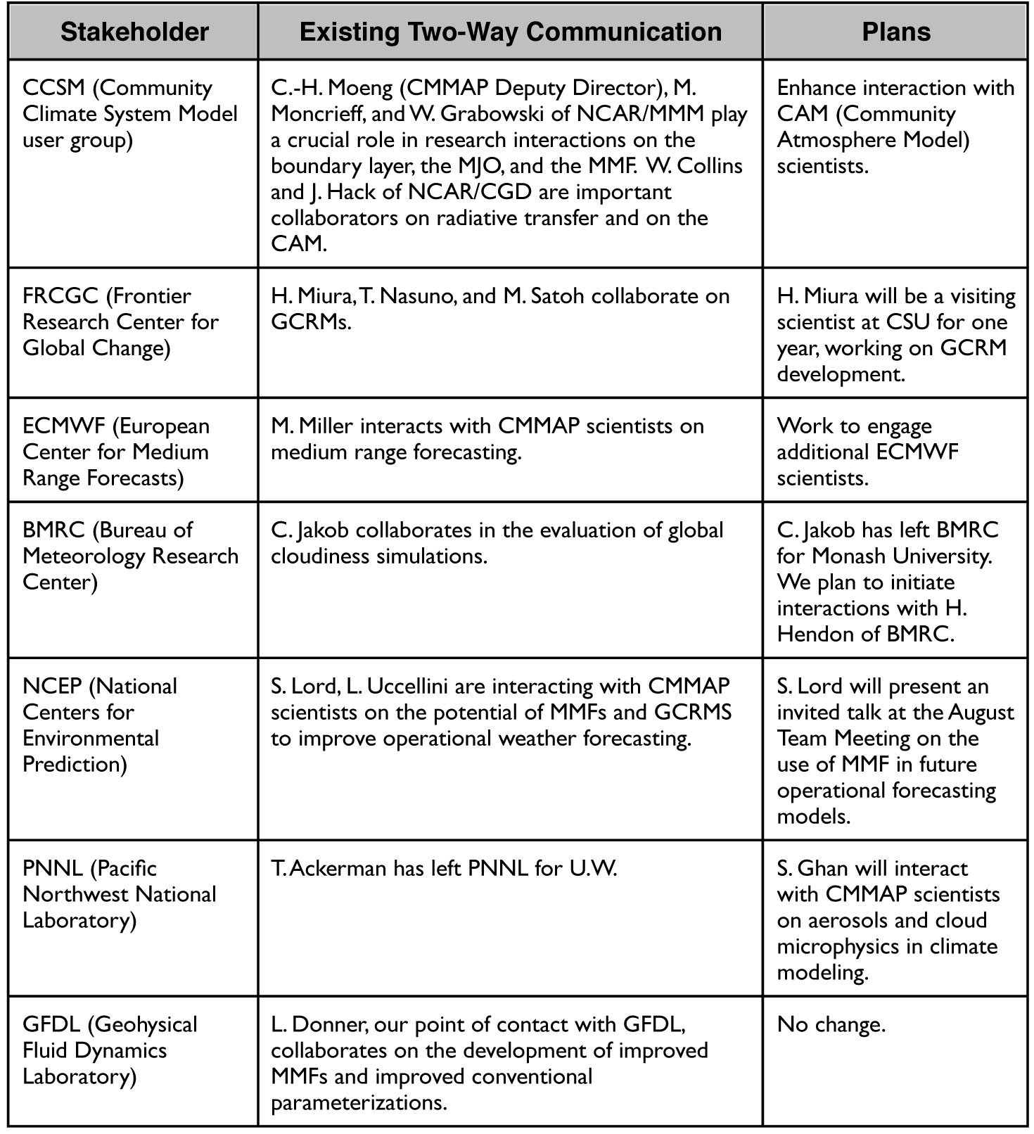

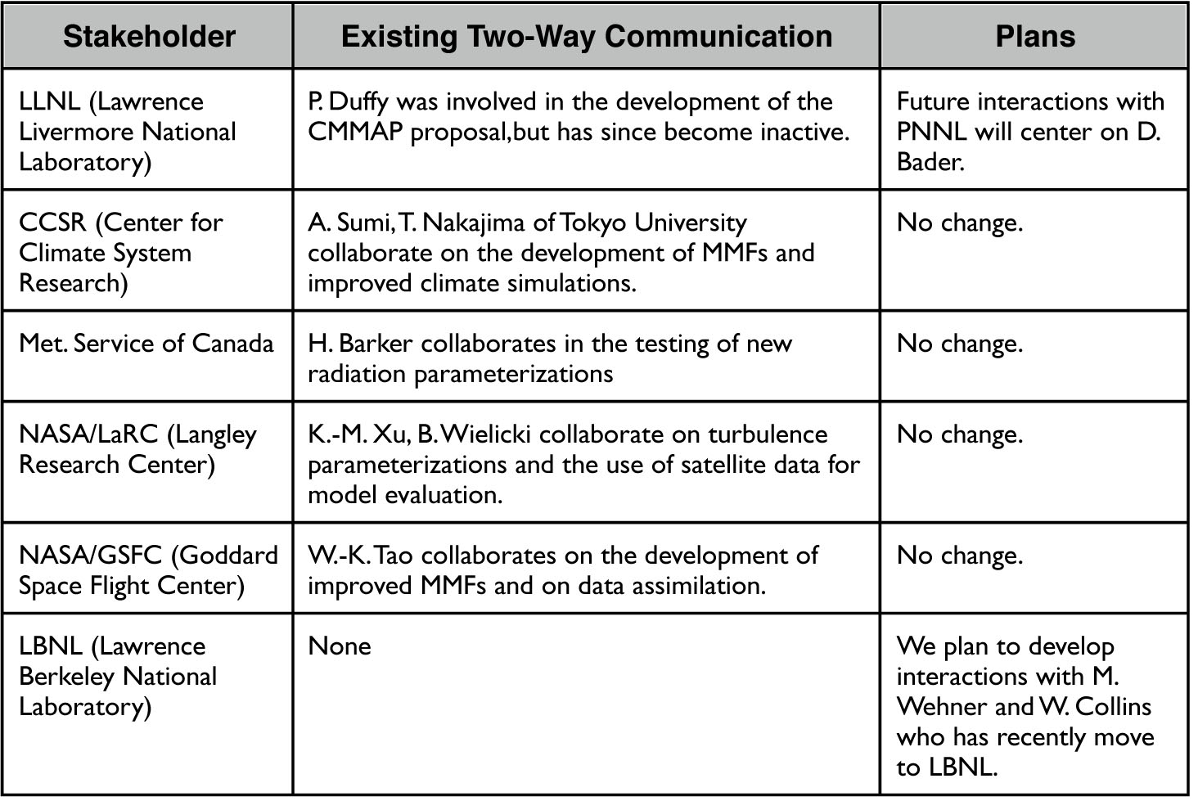

- Tools
  - Reporting (Link to CMMAP website)
  - KT record; Journal impact factors; CMMAP reference database
  - Map tool – who/where (Google Map) of CMMAP partners organizations
  - Link to Windows to the Universe Website.

