Analyzing Weather Balloon Data

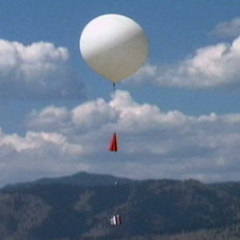

Earlier today we launched a weather balloon to gather data about the vertical structure of the atmosphere; now we will be plotting and analyzing that data. You are provided with the sounding data that we collected.

- Plot the temperature and dewpoint temperature with height, and then answer the following questions:
  - What is the lapse rate near the surface?
  - What might you look for to find a cloud layer?
  - Do you see any cloud layers in this sounding?
  - At what level is the tropopause?
  - How might this sounding change later in the day?
  - What else might you want to know in order to better forecast this?

As you can probably tell from looking outside, the weather in Colorado in July is not very exciting. You are given an example of the type of sounding that may be observed on a day when severe weather is likely. The sounding you are given is from Fort Worth, TX on May 4, 1999. Meteorologists like to call this a “loaded gun sounding”, which indicates a high potential for severe thunderstorms.
- Plot the temperature and dewpoint with height.
  - What is different about this sounding, as compared to our sounding from this morning?
  - What things might a forecaster be looking for when trying to predict the threat of severe weather?

