The following maps provide a good example of the progression of a synoptic scale storm system moving across the country (November 9-10, 1998). The first 2 are from the middle of the evolutionary cycle and would be good for use in locating weather phenomena (one of these was the example used in the summer workshop). The remaining 9 figures illustrate the entire evolution of the storm and could be used for forecasting the movement of the storm (as was done in the workshop; the first 8 were given, the last used to verify a forecast for Chicago). Note that these maps were generated from the following website: http://vortex.plymouth.edu/surface-u.html (for reproduction use variable 1: isobars/station plot and lowest plot density; date and time can be read off the maps below)

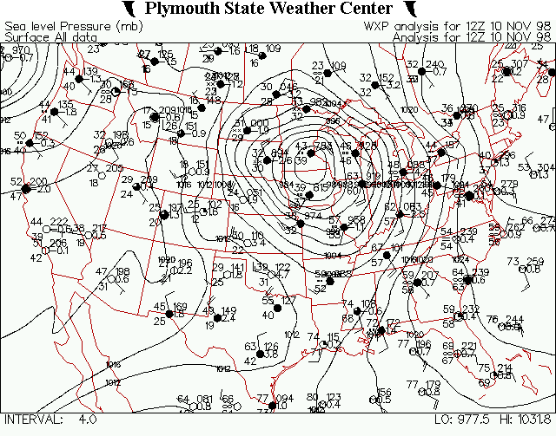

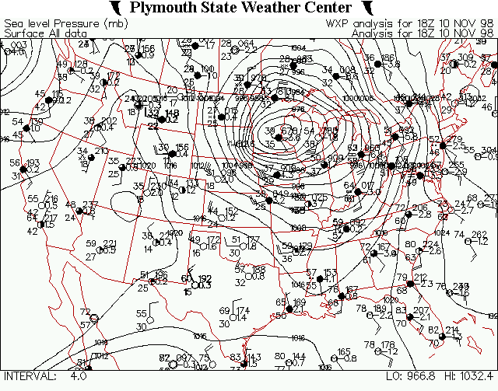

Storm Lifecycle:

