How do I measure the amount of water vapor in the air?

Materials

- 2 Centigrade Thermometers
- Gauze
- Fan
- Rubber Band
- Tape

Overview

Water vapor is a very important gas in the atmosphere and can influence many things like condensation and the formation of clouds and rain, as well as how hot or cold it feels at the surface. Different regions typically contain different amounts of water vapor and this can drastically affect the climate across these regions. Water vapor is also a necessary tool in forecasting, therefore the measurement of the amount of water vapor in the air is standard for most weather observation stations (along with temperature and wind properties). The following activities will help you become familiar with the different ways in which meteorologists express water vapor amounts as well as how to measure it.

Theory

The amount of water vapor in the air can vary greatly on regional scales and must be measured at weather stations. There are several ways to measure and express this moisture content. One is using a psychrometer, which measures the dry bulb (actual air) temperature and what is called a wet-bulb temperature. This is done by placing a wet material over one of the temperature sensors and ventilating it, causing the temperature to drop due to evaporation of the water from the material. If the air is dry, the evaporation will be stronger and so the temperature will drop more than if the air was humid. Therefore, the difference of the dry and wet bulb temperatures can be an indication of how much water vapor is in the air.

Other ways to express water vapor include the relative humidity, dew point temperature and partial pressure of water vapor (the amount of pressure the water vapor would have if it alone occupied a parcel of air). If enough of these quantities are known, they can be used along with a table of temperature and saturation vapor pressure (the partial pressure of water vapor necessary to reach saturation, or 100% relative humidity) to calculate unknown quantities of moisture content and temperature. Computation of these quantities for different regions can illustrate that water vapor varies greatly on a regional scale and that relative humidity can be a good measure of how humid it feels but not necessarily of the actual water vapor content.

Relative humidity is dependent on the temperature and the vapor pressure ($p_{v}$) of the air. Using temperature to find saturation vapor pressure ($p_{v}^{}$) (i.e. table 2), one can compute the relative humidity as: $\frac{p_{v}}{p_{v}^{}}´\text{100}\text{\%}$. Keep in mind that not only will this quantity change if the moisture content is altered, but if the vapor pressure (the actual amount of water vapor in the air) remains the same, the relative humidity will be affected by a change in temperature.

Doing the Experiment

This experiment includes multiple activities, the first of which measures the moisture currently in the air. The second activity expands upon this by allowing the participants to examine the affect moisture can have on a regional climate.

Part 1: Measuring water vapor content

- Tape the thermometers to the edge of the table with the numbers facing up and the liquid filled ends sticking over the edge of the table about 1in.
- Wet the gauze and tie it around liquid filled end of one thermometer using the rubber band
- Blow the fan on the thermometers until the temperature stops falling
- Write down the temperature on both thermometers
- Subtract the temperature on the wet thermometer from that of the dry one.
- Use table 1 to figure out the relative humidity

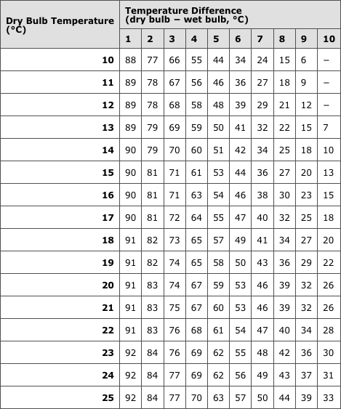
Table 1- Relative humidities based on wet and dry bulb temperature differences

The calculated relative humidity can be compared to that of the nearest weather observation station for quality check.

Part 2: Calculations of moisture content

For the second part of the activity, you will calculate and compare moisture parameters for different regions.

There are many different ways to measure water vapor in the atmosphere, the most common include dew point and wet bulb temperatures, relative humidity, partial pressure and mixing ratio. The following definitions and relationships will prove useful in this 2nd activity:

- T_{d} (dew point temperature): the temperature at which a parcel of air would condense if it cooled to that point, also called the saturation point
- T_{w} (wet bulb temperature): the temperature a parcel of air would have if cooled to saturation by evaporation of water into it. The wet bulb temperature is the temperature the parcel would have if it reached saturation by addition of water vapor, since this additional water vapor would evaporate and cool the parcel). T_{w} is between the actual temperature and the dew point.
- p_{v} (partial pressure of water vapor): the pressure water vapor would have if it alone occupied the same volume as the parcel of air
- q_{v} (mixing ratio): the ratio of water vapor mass per kilogram of dry air in any given parcel of air (g water vapor/ kg dry air)
- RH (relative humidity): ratio of partial pressure of water vapor to the saturated vapor pressure* of water at that temperature, expressed as a percent
$$\frac{p_{v}}{p_{v}^{}}´\text{100}\text{\%}$$
*Saturated vapor pressure ($p_{v}^{}$) is the vapor pressure needed in the parcel of air to reach saturation (RH = 100%), or the point at which the water will condense because the air parcel can’t ‘hold’ any more water vapor. It is dependent on the temperature of the air only and can be calculated using table 2. Also note that because of this relationship, the dew point temperature in table 2 will correspond with the actual vapor pressure of the air, while the temperature itself will correspond to the saturation vapor pressure.

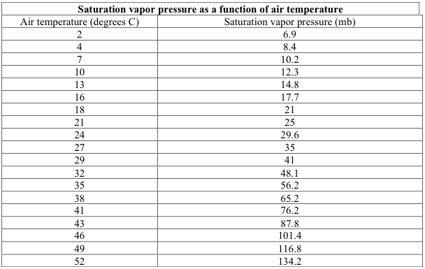
Table 2 – Saturation vapor pressure as a function of air temperature

Below are some sample questions designed to enhance your understanding of water vapor content and its regional variations.

1. Temperature = 29ºC. Dew point = 13ºC.
What are the vapor pressure, saturation vapor pressure, and relative humidity?

2. Dew point = 10ºC. Relative humidity = 50%.
What are the vapor pressure, saturation vapor pressure, and air temperature?

3. Saturation vapor pressure is 35mb. Dew point = 10ºC.
What are the air temperature, vapor pressure, and relative humidity?

4. Find the relative humidity of two cities:
- City A has an actual vapor pressure of 6mb and a saturation vapor pressure of 41mb.

- City B has an actual vapor pressure of 6mb also, but a saturation vapor pressure of 18mb.

- Which city has a higher surface temperature? How can you tell?

5. Pheonix has a surface temperature of 35ºC and RH of 15% while Fairbanks has a surface temperature of 4ºC and RH of 80%. Which of these cities has a higher water vapor content? (hint: make sure to calculate it, don’t just trust your instinct)

Summing Up

Now you should know that moisture can vary greatly in the atmosphere and plays an important role in regional climate and weather forecasting. Also, don’t judge a book by it’s cover, remember that relative humidity isn’t always the best indication of the actual water vapor content in the air.

