If you want to extend the weather map and forecasting lab to include contouring and upper-level weather data, here is some useful information for doing this.

Contouring

Isopleths are lines that connect equal values of some quantity. Examples include:
- Isotherm; line of constant temperature, usually at 5 or 10oF intervals
- Isodrosotherm; line of constant dew point (5 or 10oF intervals)
- Isobar; line of constant pressure (4mb intervals)
- Isotach; line of constant wind speed (5 or 10 knot intervals depending on if it’s a surface map or an upper level map)
- Isoheight; a line of constant geopotential height on a constant pressure surface chart (50 geopotential meter -gpm- intervals)

Contouring is the act of drawing these isopleths on a weather map. Notice on contoured weather maps that the closer the contours/lines/isopleths are together, the more rapidly that value is changing over a shorter distance. This is a good way to identify meteorological phenonema such as cold and warm fronts.

Rules for contouring:

1) Isopleths should never cross.
2) Isopleths should not branch or fork.
3) Do not draw isopleths where there is no data.
4) Label at both ends, and color code the isopleths.
5) Isopleths can form closed loops.
6) Eliminate what appears to be incorrect data.
7) Start with locating highest and lowest values.
8) Interpolate between given values.
9) Lines should be smooth.

Example: (please also reference surface and upper air maps included in the lab activity)

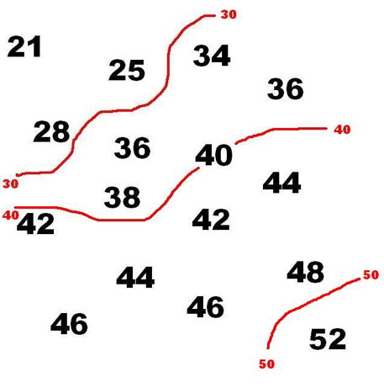
Figure 1

Upper Level Map

The height of a column of air can be changed based on the mass in the column and the temperature (density) of the column. Thus, the height of a given pressure above the surface can change from place to place depending on the mass and temperature of the column overhead, see figure 2. The height of a given pressure can be contour plotted in a manner similar to a topographical map, see figure 3.

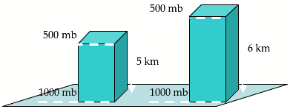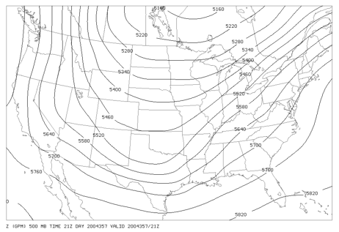

Figure 2 Figure 3

[Note: Similarly to surface station plots, upper air maps often abbreviate geopotential heights by plotting in decameters (10’s of geopotential meters). For example, 540 on the the map in figure 4 would refer to 5400 gpm (geopotential meters)]

Locate features on the map associated with weather (i.e. figure 5). Troughs are associated with cooler temperatures, low pressure and precipitation and are usually located to the west of surface low-pressure centers. Ridges are associated with warmer temperatures, high pressure and stability. Upper level flow patterns can strengthen or weaken surface weather phenomena and are a very useful forecasting tool. Use your knowledge of these interactions to help create forecasts in the lab.

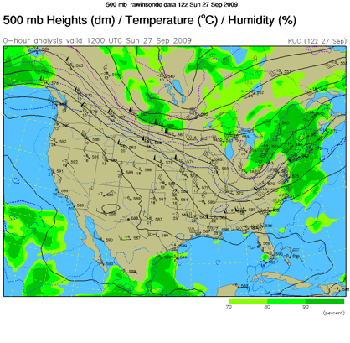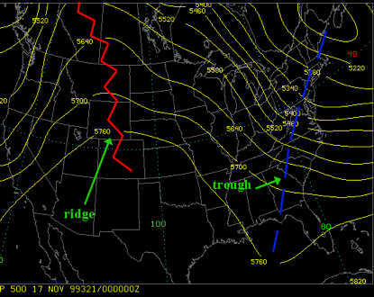
Figure 4 Figure 5

