Locating Weather Phenomena on a Weather Map

Low Pressure Center: Area of lowest pressure
High Pressure Center: Area of highest pressure
Cold Front:
- Rapid temperature change (usually cooling from E to W)
- Usually precipitation directly behind cold front
- Wind shift from S or SW to W or NW with passage of front
- Usually lie along pressure trough, or kink in isobars (lines of constant pressure)
- Clouds often of a cumulus nature along front
Warm Front:
- Temperature change (usually warming from N to S)
- Wind shift from E or NE to S or SW with passage of front
- Fog or stratus clouds with light precipitation usually accompany the warm front
Stationary Front*: Boundary between cold air and warmer air, identified by a temperature shift, however, winds blow along the front and so it doesn’t tend to move unless perturbed
Occluded Front*: If the cold front has caught up to the warm front, then it becomes an occluded front which spirals into the low pressure center
Dry line*: A boundary between the warm, moist air from the Gulf of Mexico and the warm, dry air of the Southwest United States. Identified by a rapid shift in dewpoint. Can sometimes act as initiation of convection, much like a cold front, as the dry air tends to be more dense than the moist air and wedges underneath it (creating lifting similarly as a cold front would)

*Not always present and not necessary for simple weather map analysis

Marking Locations:
- Low pressure center: L
- High pressure center: H
- Cold front: Blue line with triangles indicating direction of frontal movement
- Warm front: Red line with semi-circles indicating direction of frontal movement
- Occluded front: Purple line with alternating triangles and semi-circles indicating direction of movement of the front
- Stationary front: Alternating red line with semi-circles and blue line with triangles on either side of the front (blue triangles point to cold air while red semi-circles point to warm air)
- Dry line: Brown line with semi-circles pointing into the moist air

Examples:

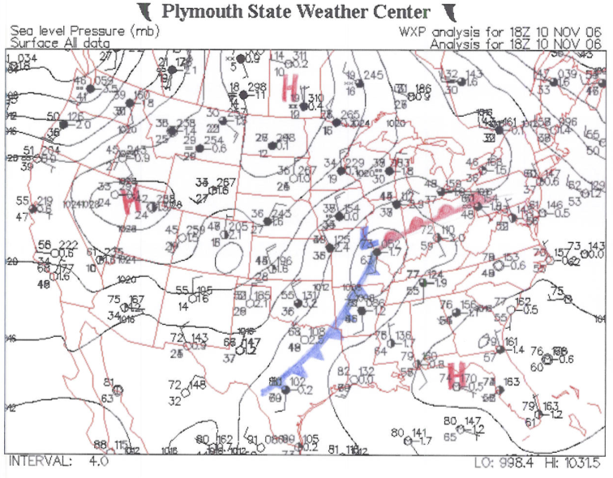
Figure 1

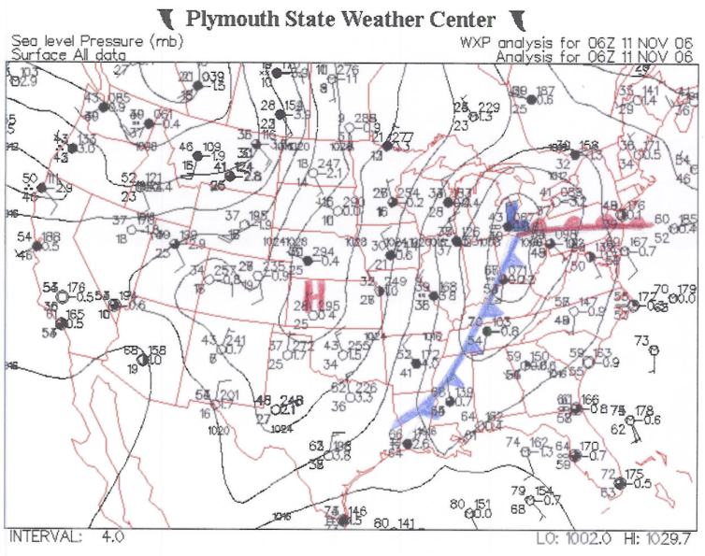
Figure 2

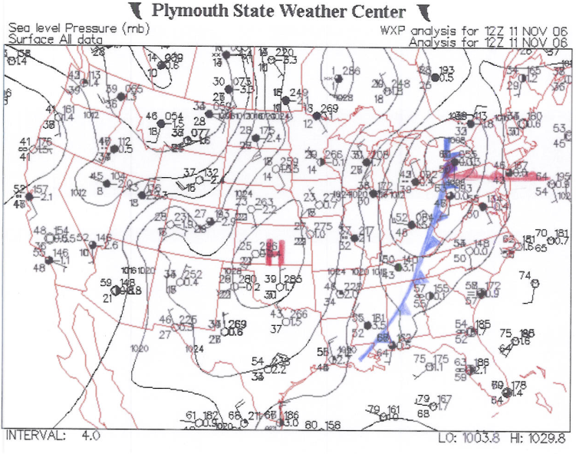
Figure 3- Arrow points to the start of an occlusion

Low-pressure weather systems carry much of the weather across the country and are crucial to forecasting in many areas. Knowledge of the location of a low-pressure center and the weather patterns associated with it (i.e. cold and warm fronts and the precipitation that tends to go along with those) is necessary for this prediction. This is why it is important to understand the movement of the storm system across the country by tracking the trail it took and using it to predict future movement.

Mark an X (or an L for low-pressure) on the weather map in the location of the low-pressure center for each day (either on the maps themselves or on a transparency paper). Use this information to predict the new location on the following day as well as the weather in a city nearby.

Example (for this case, a good city to forecast the following’s day weather might be Pittsburgh or New York City):

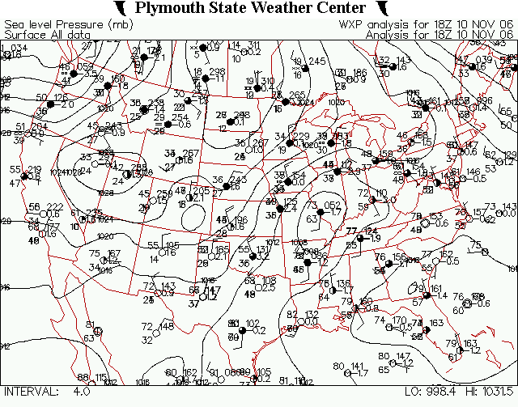
Figure 4

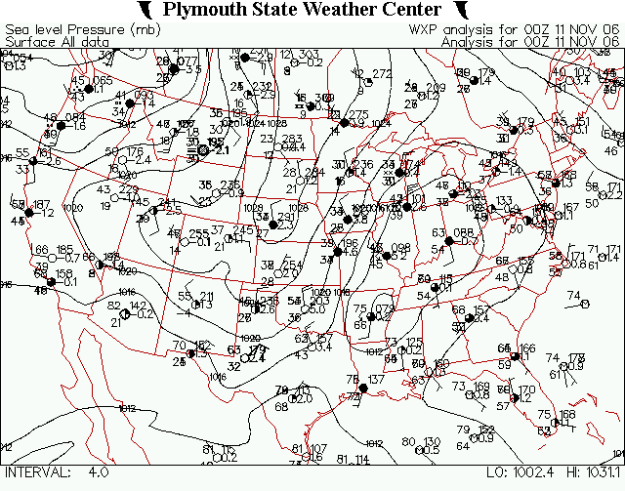
Figure 5

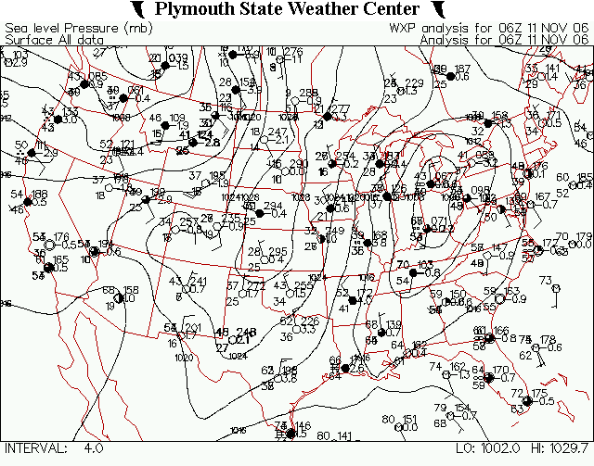
Figure 6

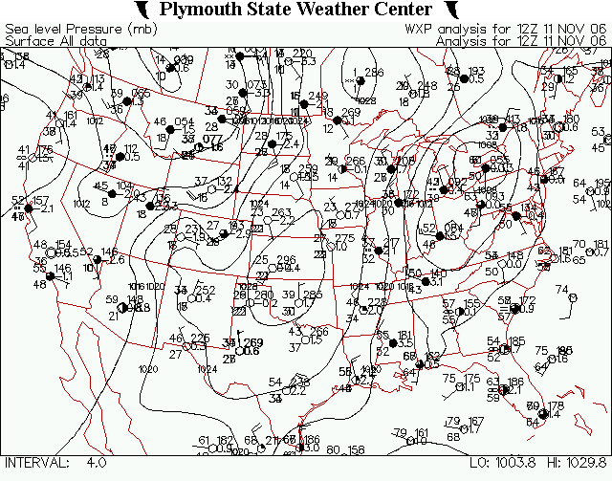
Figure 7

