Climate Map Mystery Activity

By Vicky Jordan (Wellington Middle School) and Jeanette Anderson (Artist)

**Overview** – *This activity will take at least 2 block periods to complete. Part 1 & 2 should be done together.*

Teams of students will use a table-top map of the world to accomplish 3 tasks:

1. Use plastic-laminate strips to make “loops” to represent air flow in Hadley, Ferrell, and Polar Cells over the correct latitudes on the map;
2. Use a statically-charged plastic loop and Styrofoam or small paper pieces to model the movement of moisture in each Cell. Based on this, identify where on the map each climate type would be expected.
3. Match plant and animal picture cards with written descriptions of the organism and identify adaptations of each. Then, using the adaptations, predict where on the map each would live based on the expected climate of the area.

Assessment and accountability: Students will complete an individual, personal map that includes each task.

**Colorado** **Science** **Standards** *(as of 2012- grade level in parentheses)*

* Water on Earth is distributed and circulated through oceans, glaciers, rivers, ground water, and the atmosphere. (6th)
* Earth has a variety of climates defined by average temperature, precipitation, humidity, air pressure, and wind that have changed over time in a particular location. (8th)
* Individual organisms with certain traits are more likely than others to survive and have offspring in a specific environment. (7th)
* Distinguish among, explain, and apply the relationships among mass, weight, volume, and density. (6th)

**Lesson Objectives**- Students will be able to:

1. Model how the general circulation of the atmosphere determines Earth’s climate zones (tropical, subtropical, temperate, and polar.)
2. Identify latitudes where Hadley Cells, Ferrel Cells, and Polar Cells transport air aloft and back to the Earth’s surface.
3. Using a map of the world, trace the flow of moisture in Hadley Cells, Ferrel Cells, and Polar Cells. Explain why certain latitudes are wet, and others are dry.
4. Using the concept of density and convection, explain how the sun is the “engine” that drives the movement of air on Earth.
5. Determine adaptations of plants and animals suited for each climate zone, and correctly identify where in the world a particular plant or animal probably lives based on the adaptations for a particular climate.

**Materials for each team of 4 students**

* Table-top map of the world with latitude lines of 0, 30, 60, and 90 degrees north and south
* Six plastic, laminate strips to represent Hadley Cells (2), Ferrell Cells (2), and Polar Cells (2)
* Climate Map Mystery Cards - picture cards, organism description cards, and name cards (11 of each)
* Four vis-à-vis (wipe off) markers to use to draw on the laminate strips
* Shredded Styrofoam or paper pieces to represent moisture traveling through the atmosphere
* A piece of wool or silk cloth to create static electricity on the plastic strips
* Climate Zone name cards (7). *Optional: Landscape materials - something to represent each climate zone that could be placed on the map: sand for deserts, plastic tree models for tropics (deciduous) and temperate (pine), astro-turf for grasslands/savannah, shredded paper or styrofoam for snow, etc.*
* Scissors, colored pencils, highlighters, tape, student cut-out sheets and personal maps for each student

**Background**

Prior to doing this activity, students need to understand the concept of density and convection, and know that the Earth is warmed by the sun more at the equator than the poles.

**Theory**: See Scott Denning’s CMMAP activity on Climates of the World, and his description of Hadley, Ferrel, and Polar Cells for excellent information that is user-friendly! Visit <http://cmmap.colostate.edu>

**Doing the Activity**

Break students into heterogeneous teams of 4. Have students select a role for the day:

* **Convection Conveyer** (in charge of directing air flow in Part 1)
* **Water Spouter** (in charge of directing water flow in Part 2)
* **Zookeeper** (in charge of directing animal and plant placement in Part 3)
* **Go Getter** (in charge of getting materials as needed and supervising clean up)

Reinforce that all students will participate fully in all activities, but a different person will be “in charge” of each step. The teacher is the **Climate Controller**, and will check in with teams at particular points in the activity.

**Part 1 – Air Flow**

Give each team a table-top map and an individual 8 ½ X11map for them to draw on and makes notes on for their notebook. Give each team a set of student directions (best to tuck this in to a sheet protector first.) Be sure the “Go Getters” know where all the supplies are, and what the expectations are for use and clean up! Be sure students understand that the “cell” goes all the way around the globe, and is not just a narrow loop of air! A way to improve the model would be to have a “tube” of air that goes all the way around the globe instead of just a strip to show what the air does at one location.

**Part 2 – Atmospheric Water Circulation Creates Climate Zones**

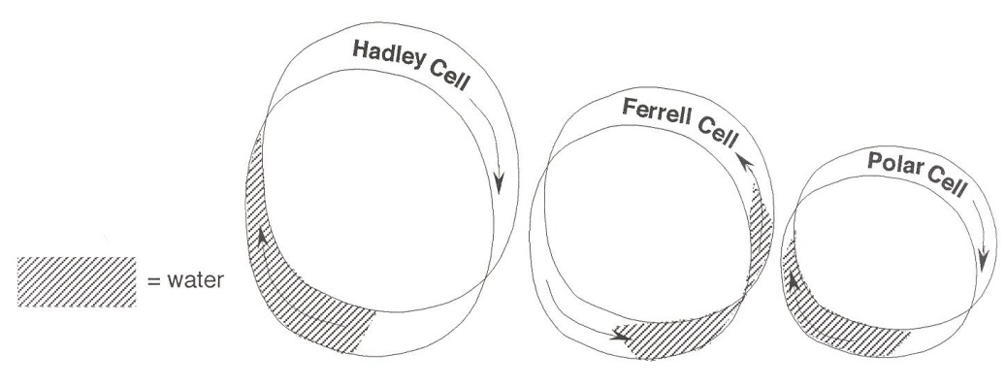During student discussions, circulate around to all teams and make sure they are moving the plastic strips correctly, adding and subtracting the “water” pieces at the appropriate locations. Students should color in their personal map as they go with the climate zones. If you have the optional “landscape materials,” be sure students are given expectations about their use. Many students will benefit from this additional “hands-on, minds-on” three-dimensional expression of the map if there is time and materials. Give students the “cut out” page after they have completed their discussions. The most difficult part for the students will be the final step of coloring in their Cell loops on their personal map with the locations where most of the water will be found. Students will have to squish or fold the loop down to color it.

**Part 3 – Plant and Animal Adaptations**

Students will first match the word, picture, and descriptions for 11 species. Then, they will place the name of the organism on one of the numbered boxes on the large map based on the climate of the area and the adaptations listed in the description. The teacher will come around and check that each card is properly placed before the students can move on and complete the student response sheet. *(Tip: turn correct cards face down on the map, and have students re-evaluate the face up mistakes. In this way, you can float around the room checking maps and not have to re-check correct answers!)*

#1 Alaska - Walrus (*Odobenus rosmarus*)

#2 Canada - Fisher (Martes pennanti)

#3 Finland - Scots Pine (*Pinus silvestris*)

#4 Russia - Trehpaly Woodpecker (*Picoides tridactylus*)

#5 Sahara – Scorpion (no scientific name given because a specific species is not identified)

#6 Brazil (Amazon Basin) – Bromeliad (no scientific name given because a specific species is not identified)

#7 Rwanda - Mountain Gorilla (*Gorilla beringei*)

#8 Philippines- Panther Flying Frog (*Rhacophorus pardalis*)

#9 Argentina (central in the desert) - Night blooming Cereus (*Cereus aethiops*)

#10 Australia (central in the desert) - Bilby (*Macrotis lagotis*)

#11 Antarctica - Adelie Penguin (*Pygoscelis adeliae*)

**Climate Mysteries**

Student Directions

Work together to select a role. Make sure everyone is happy with their role!

* Convection Conveyer (in charge of directing air flow in Part 1)
* Water Spouter (in charge of directing water flow in Part 2)
* Zookeeper (in charge of directing animal and plant placement in Part 3)
* Go Getter (in charge of getting materials as needed and supervising clean up)

**Part 1 – Air Flow**

1. **Go Getter**- Go get 6 plastic strips, four vis-à-vis markers, and some tape.
2. **Convection** **Conveyer** – You are in charge of reading these directions out loud and making sure everyone is participating.
3. Each person should help label. On two strips, write “Hadley Cell.” On 2 strips, write “Ferrel Cell.” On 2 strips, write “Polar Cell.”
4. On each strip, draw arrows pointing from one end to the other, all going the same direction. These arrows will represent air flow.
5. Make each strip into a loop, and tape the ends together so it remains a loop.
6. Read the information on Hadley, Ferrel, and Polar Cells out loud together. As you read, try to place each plastic loop (Cell) in the proper place above the map. Be sure the arrows for air flow are in the right direction. Have the Climate Controller (your teacher) check your work when you think you have done it correctly. *Note: On the planet, the Hadley Cell is bigger than the Ferrel and Polar cells, but to make this model work, all the plastic cells are the same size.*
7. **Go Getter**- Get a “cut out” sheet and scissors for each person. Everyone needs to cut out the Cell strips, draw the arrows, make the loops, and place them correctly on their own personal map.

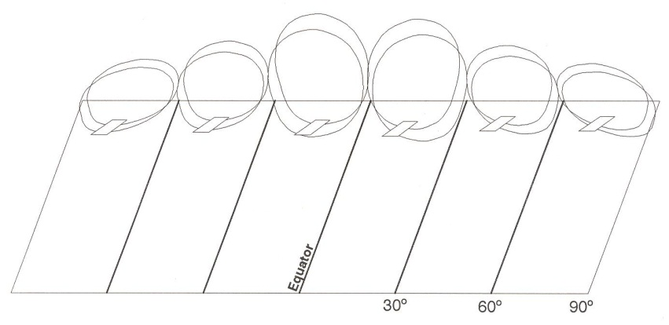

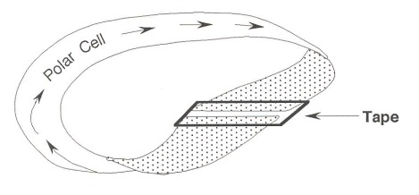

**Climate Mysteries**

Student Directions

**Part 2 – Water Movement in the Atmosphere Creates Climate Zones**

1. **Go** **Getter** –Go get a baggie of tiny styrofoam beads or shredded paper. Get a set of 8 climate cards. Be sure your team has colored pencils and personal maps. (Return unneeded supplies from Part 1.)
2. **Water** **Spouter** - You are in charge of reading these directions out loud and making sure everyone is participating. You will need 2 people to follow the directions to move the plastic strips properly over the map. One person will move the strips over the northern hemisphere, and one over the southern hemisphere.
3. On your personal map, make a climate key in one of the margins. Pick a different color for each climate zone (4 of them): tropical, subtropical desert, temperate, polar.
4. If the plastic strips (Cells) do not have static electricity, rub them with a piece of wool cloth. Check to see that they will pick up the Styrofoam beads or paper pieces if you spin the loop over them.
5. The plastic strips (Cells) will represent air, and the styrofoam or paper pieces will represent water in this model.
6. **TROPICS** – Using the big table map, sprinkle “water” pieces at the equator on an ocean. Roll each Hadley Cell loop (between the equator and 30O)in the proper direction for air flow over the “water” so the static electricity will pick up the pieces. When the “water” gets near the top of the loop, brush the “water” off of the “air”, since rain will fall because the water condensed as it cooled. *(Hint: You can use the edge of a ruler as an effective way to brush the water pieces off of the plastic cell right as they reach the top of the rising air mass.)* Be sure all (or nearly all) of the water is removed from the air. The rain should fall close to the equator. Talk with your team about why there are rainforests in these regions, based on your model. Place one “Tropics” card somewhere on the equator . Have the Climate Controller come over once you all agree on an answer to check your thinking*. On your personal map, shade in the latitudes where there are tropics with the appropriate color.*
7. **SUBTROPICAL DESERTS** - Notice the now dry air (plastic loop with no paper attached) is moving back down toward Earth at 30O, following the Hadley Cell arrows. Notice that the region of the world where the dry air reaches Earth contains the world’s largest deserts. Identify areas on the map that you know of that have deserts. Talk with your team about why there are deserts in these regions, based on your model. Place one “Subtropical desert” card in the northern hemisphere, and one in the southern hemisphere. Have the Climate Controller come over once you all agree on an answer to check your thinking. *On your personal map, shade in the latitudes where there are deserts with the appropriate color.*
8. **TEMPERATE** - Recharge the loops, if needed, with more static. Put some “moisture” (Styrofoam or paper) on the map between 30 and 60 degrees. Spin the loop of the Ferrel Cell in the direction of air flow. As the air passes between 30 and 60 degrees latitude, allow the loop to gather the moisture (pick up some more styrofoam or paper pieces.) Remember that this is another reason that the deserts exist here. The moisture at ground level gets pulled away from 30O and moves back to the equator or up to 60O. Continue to spin the now moist loop up along the Ferrel Cell lines that show air flow. When the moisture gets near the top of the Ferrel Cell, make it rain. Notice that at this latitude (60 degrees) you find grasslands, temperate forests, and savannahs. Discuss with your team why these plants can grow here, based on your model. Place one “Temperate” card in the northern hemisphere, and one in the southern hemisphere. Have the Climate Controller come over once you all agree on an answer to check your thinking. *On your personal map, shade in the temperate latitudes with the appropriate color.*
9. **POLAR** – Now spin both the Ferrel Cell and the Polar Cell together. If you put moisture on the ground under the Polar Cell, it should rise with the moisture on the Ferrel Cell. Knock it off (rain/snow) just before it gets to the top. Notice that the moisture rises and precipitates in both cells at 60O. The Polar Cell can “grab” the now dry air that is rising from the Ferrel Cell and pull it toward the poles aloft (in the air), not along the ground. Your now dry air will then descend towards the ground at the poles. Discuss with your team why the Arctic and Antarctica are dry and cold, based on your model. Place one “Polar” card in the northern hemisphere, and one in the southern hemisphere. Have the Climate Controller come over once you all agree on an answer to check your thinking. *On your personal map, shade in the polar latitudes with the appropriate color.*
10. *On your personal map, color or decorate the Cell loops to show where the water is.* Only part of each Cell loop will be decorated. You will color or decorate the sides of the loops that had the styrofoam or paper pieces attached. Along with your coloring of the climate zones, this will be your assessment for this part! Call the Climate Controller over to check your work.

**Climate Mysteries**

Student Directions

**Part 3 – Adaptations for Survival**

1. **Go Getter** – Go get Climate Map Mystery Cards - picture cards, organism description cards, and name cards (11 of each.) Put away materials from Parts 1 & 2 if necessary.
2. **Zookeeper** - You are in charge of reading these directions out loud and making sure everyone is participating.
3. Deal out all 33 cards so that everyone has nearly an equal amount. In order to ensure that everyone is thinking, you must always “give one/get one” in exchanging cards. This is not a competition, but a cooperation! Read your description cards out loud to the group, and try to match the name card and the picture card to the descriptions. Each person should end up with 2 or 3 matching sets by the end, so rearrange things to make this happen if you need to. These are now “your species.” Have the Climate Controller (your teacher) come and check your matches before proceeding.
4. Each person is in charge of determining where on the map their species live. Using the descriptions, find adaptations that would help your species survive in a particular climate. Explain your reasoning to the group. If someone has input or disagrees, listen carefully to their arguments and evidence, and then feel free to change your mind based on new evidence. Remember, that’s what good scientists do! Place the name card into the box on the appropriate location on the map. Once all the species have been placed into the numbered boxes, call the Climate Controller over to check your work.
5. Once you have all the organisms placed correctly, write the names of each organism onto the correct location on your personal map. Then, answer the questions on the student response sheet. It’s OK to discuss the questions and answers with your team, but each person should try to write responses in their own words.

Atmospheric Circulation and Climate Zones

Student Background Reading

*By Vicky Jordan, inspired from an original article by Scott Denning, Colorado State University CMMAP*

<http://cmmap.colostate.edu>

What causes air movement in the atmosphere? How does this movement affect the climate in every part of Earth? It all has to do with the sun’s energy heating the Earth more at the equator than at the poles. The sun is the “engine” that drives the motion of the air around the globe. There are 3 main convection cells that carry air and water around the planet; the Hadley Cell, Ferrel Cell, and Polar Cell.

As you know, when air is heated, it expands becoming less dense and more buoyant. At the equator, where there is a lot of solar energy, the air rises fast and far, carrying with it a lot of water vapor. As the air reaches the top of the troposphere, having pushed away surrounding air and losing heat energy in the process, it cools. When the molecules cool, the water vapor condenses, forming clouds and the chance of precipitation. Rain falls heavily in the **tropical climate**. The air at the top of the convection cell circulates toward the pole until it becomes more dense as it cools. The cool, now dry air sinks back toward the Earth at about 300 latidude, both north and south of the equator. This convection current is called a **Hadley Cell**. It is what causes tropical climates along the equator, and deserts or subtropical climates at about 300 in both hemispheres. As the dry air is pulled away from the 300 latitude, it gathers moisture, pulling the moisture away from the area around 300, and creating a very warm, dry **subtropical climate** or desert. *Stop here, and put your laminate Hadley Cells in the appropriate places on your big map. Call the Climate Controller (teacher) over to check your work before proceeding.*

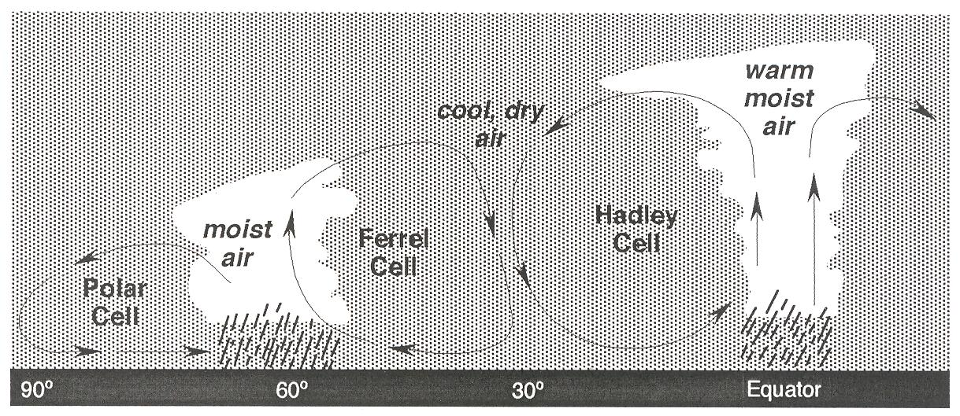

The **Ferrel Cell** is caused by air moving along the surface of the Earth toward the poles from 30 to 600 latitude. At around 600, the air has warmed sufficiently to rise once again, carrying with it the moisture it has gathered along the way. As the air rises, it cools, and drops the moisture as rain or snow. This creates a **temperate climate** zone around 600 with temperature and moisture conditions that are not extreme. In this climate zone, most grasslands, croplands, temperate deciduous and pine forests exist. *Stop here, and put your laminate Ferrel Cells in the appropriate places on your big map. Call the Climate Controller (teacher) over to check your work before proceeding.*

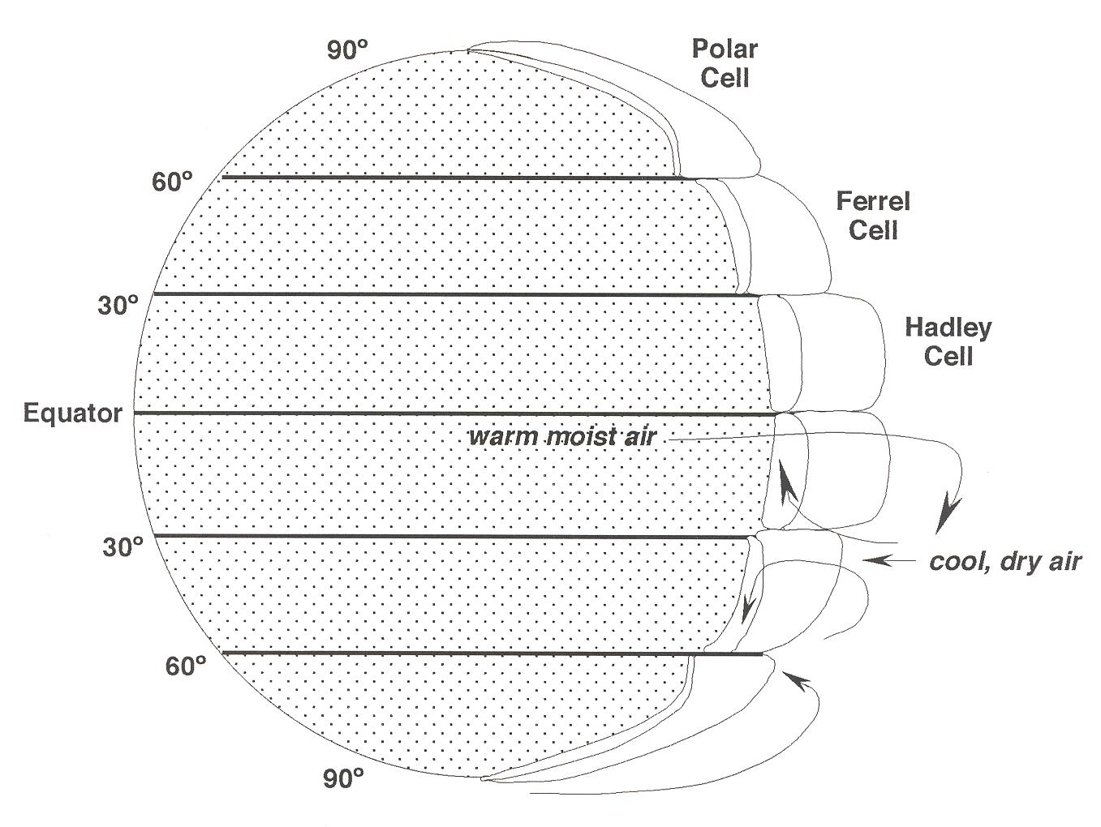

As the air from the Ferrel Cell rises, some of it moves north at the top of the convection cell, and some moves south. If the air moves toward the pole, it becomes part of the **Polar Cell**. Since most of the moisture fell as precipitation over the temperate zone, it is now dry, cold air that arrives at the poles (900 latitude.) This makes the arctic and Antarctic regions of the planet have extremes in moisture (like a desert). Because the sun’s rays are indirect in the summer, and non-existent in the winter at the poles, there are extreme temperature variations as well in this **polar climate**. *Stop here, and put your laminate Polar Cells in the appropriate places on your big map. If you have landscape features available, place them in the appropriate climate zones. Call the Climate Controller (teacher) over to check your work before completing your own personal maps. See the directions sheet for what to do next!*

Science Name ___________________________

Per ______ Date __________________

Climate Mysteries - Student Response Sheet

1. Why is Earth warmer at the equator, and colder at the poles? *(HINT: Same reason we have seasons.)*

2. Pick a latitude. Describe what the climate is like at that latitude, and explain **why** using the term Hadley Cell, Ferrel Cell, or Polar Cell. Describe how the movement of air affects the moisture in that latitude as well as neighboring latitudes.

3. Pick a latitude. Describe common adaptations that you would expect to find in a plant and adaptations in an animal in that latitude, and explain **why**. *(General terms, not specific to a particular species. For example: conserve water, shed water, deal with harsh winters, etc, and then explain how a typical plant or typical animal might deal with that situation.)*

4. Pick an organism from the cards at your table. Name two adaptations that organism has, and explain how the climate or environment favors those adaptations.

**Pre-AP/ Advanced – Pick ONE of the following to answer.**

5a. The planet was formed long before life evolved. Why did the circulation of air in our atmosphere make it impossible for bilbies to evolve and live at the equator, or bromeliads to live in Antarctica? Explain your thinking with specific examples and details.

5b. Look back at your answer to question #2 where you described how the movement of air affects the moisture in that latitude as well as neighboring latitudes. Now, explain WHY the climate zones exist where they do on the planet. Be sure to mention all 4 climate zones in your answer, with specific latitudes and climate zone names, and something about the temperature and precipitation in each.

|  |  |
| --- | --- |
| Tropical |  |
| Subtropical Desert | Subtropical Desert |
| Temperate | Temperate |
| Polar | Polar |

Science Name ___________________________

Per ______ Date __________________

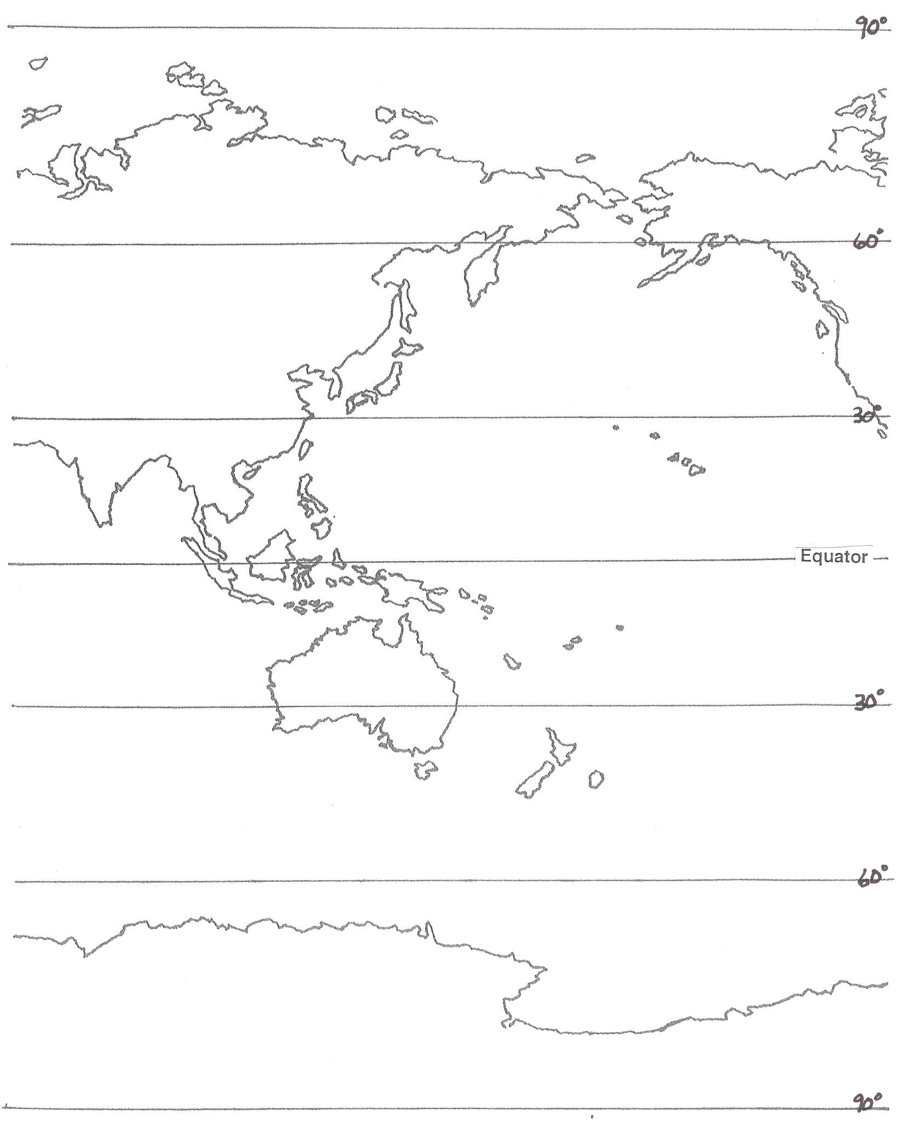

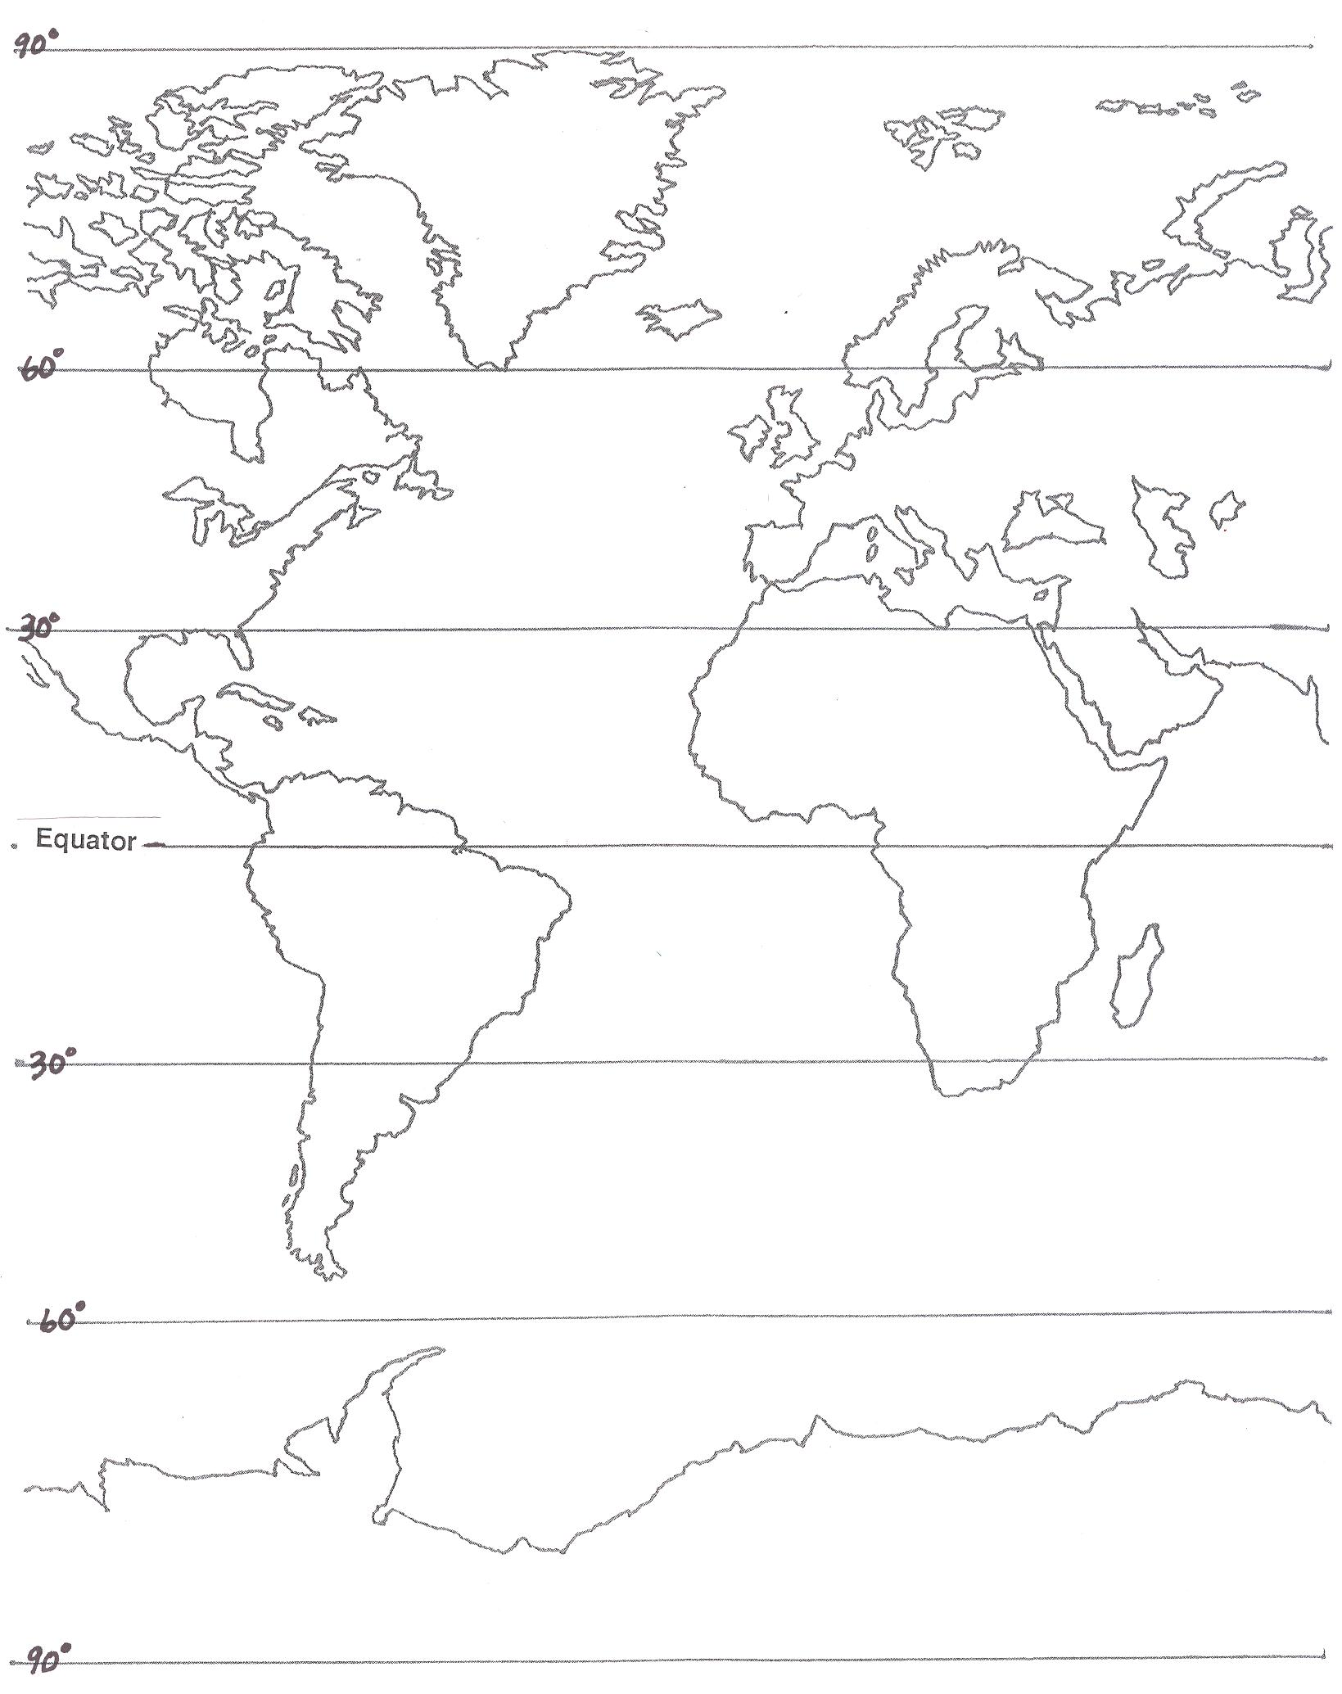

Cut-out strips for each team to place on their personal map.

