Panther flying frog (Rhacophorus pardalis) - All amphibians must keep their skin moist, so must live in areas of high humidity or where there is a lot of water, usually in areas that are warm at least most of the year. The panther flying frog has special adaptations for gliding, including extra flaps of skin and webbing between fingers and toes to generate lift during glides. The frog glides down from trees to breed in plants suspended above stagnant bodies of water. | 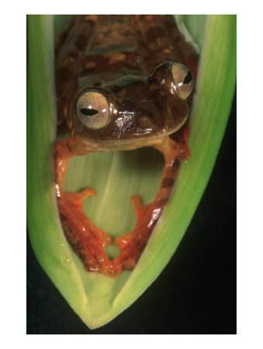
Mountain Gorilla (Gorilla beringei) - The mountain gorilla is primarily an herbivore; the majority of its diet is composed of the leaves, shoots and stems (85.8%) of 142 plant species. It also feeds on bark, roots, flowers, and fruit, as well as small invertebrates. Twenty-five distinct vocalizations are recognized, including grunts, barks, screams, roars, and rumbling belches, many of which are used primarily for group communication within dense vegetation. The long hair on mountain gorillas is suited for the cloudy, misty, and cold, high elevations in which they live. | 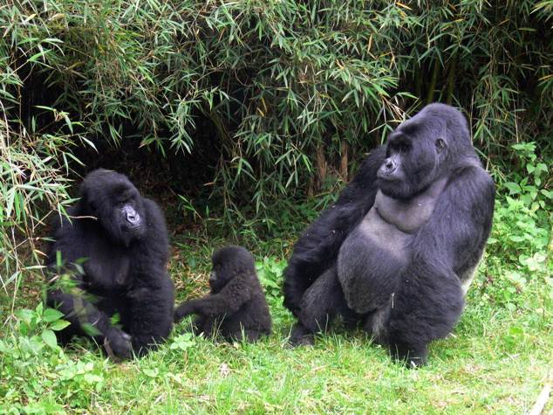
Bromeliad - There are more than 2700 different bromeliad species. This "air plant" grows on the bark of other plants, getting their water and nutrients from the air. They "hitch a ride" up to the top of the canopy on tall, fast-growing trees in order to reach the sunlight, the most valuable commodity to plants in dense forests. A very interesting thing about the bromeliads is that their leaves, being overlapped, can hold water from the rainfall. This creates a micro ecosystem for aquatic micro organisms, insects and even very tiny frogs, salamanders and snails. Some animals can live their whole life in this bromeliad little lake. | 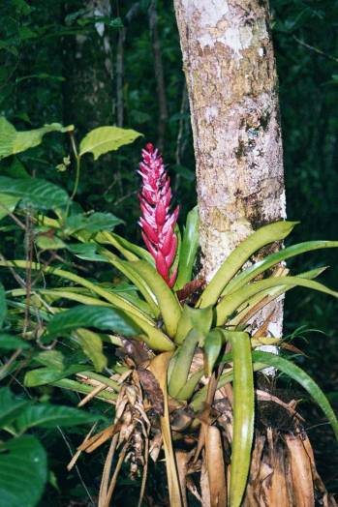

Scorpions are the insect most commonly associated with deserts. They have pedipalps, equipped with powerful pincers used to grasp prey such as other insects, which are then immobilized by stinging if necessary. Four of the Sahara's 30 scorpion species are lethal to humans. In humans, their venom can cause temporary paralysis, convulsions, cardiac arrest or respiratory failure. The scorpion limits its activities to the night, burrowing into the cooler sands beneath the desert's surface during the day. It absorbs water from the flesh of its prey. | 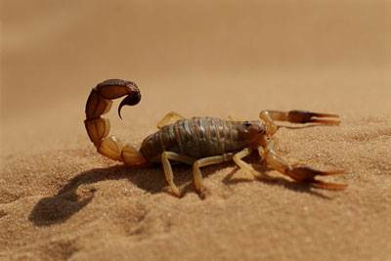
Night blooming Cereus (Cereus aethiops) - The cereus cactus has long spines to protect the photosynthetic stem from nibbling herbivores. They grow in sandy soils with limited moisture. Night blooming cereus flowers are white, large, and fragrant to attract pollinators who are also avoiding the heat of the day. Most of the flowers open after nightfall, and by dawn, are in the process of wilting. | 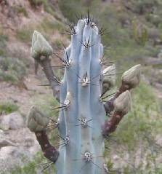
Bilby (Macrotis lagotis)- Like most desert animals the bilby hides during the day and forages at night to avoid heat and dehydration. Bilbies use their strong forelimbs and long claws to dig burrows that are one to two meters below ground and are moister and up to ten degrees cooler than the surface. Their large ears radiate heat to help them stay cool. They are so efficient in conserving water that they don't need to drink. They get enough moisture from their food: seeds, bulbs, fungi, spiders and insects, which they find by scratching and digging and using their keen sense of smell. The bilby's marsupial pouch carries babies and faces backwards to keep out the dirt from digging. | 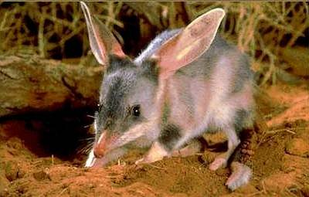

Scots Pine (Pinus silvestris) - The leaves on this plant are pine needles which can continue to photosynthesize during freezing temperatures in the winter. The bark of the tree protects the water in the stem from freezing as well. The roots of the tree spread out laterally because the soil is thin over bedrock, and this allows the tree a large surface area to capture the moisture, particularly during spring runoff when the snow is melting. The pine cones are pollinated by wind carrying the pollen from one tree to the next. | 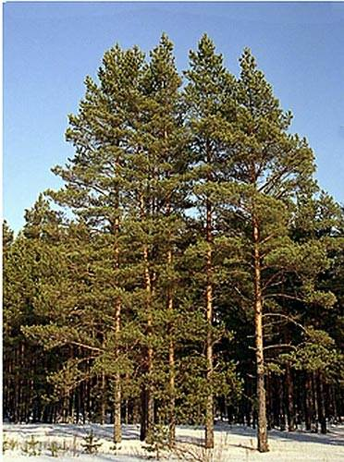
Fisher (Martes pennanti) - The fisher is a carnivore and an exceptional predator. It is one of the few animals that eats porcupine. When hunting other prey, such as mice, chipmunks, squirrels, snowshoe hares, and fawns, the fisher attacks its prey from behind. It's fur is thick and long in the cold winter months. The fisher finds shelter in holes in the ground, hollow trees, logs and stumps. They only maintain a permanent den when raising their young. Fishers have short legs and strong, large feet with hairy soles that protect them from cold and help them walk on snow in the winter. It has sharp, partially retractable claws on each of its five toes that help it dig, climb trees, and rip it's prey. | 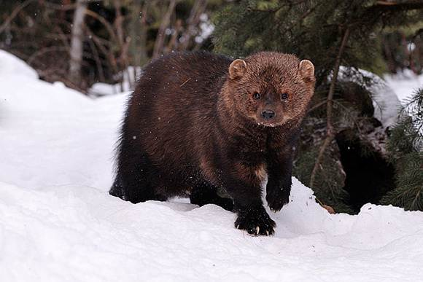
Trehpaly woodpecker (Picoides tridactylus) - This bird has only 3 toes, two that grip the bark of a tree upwards, and one that grips downward to allow it to walk up and down the tree trunk easily. Like other woodpeckers, they have stiffened tail feathers that prop against the trunk to help them balance and give them leverage. The strong bill's chisel-like tip is kept sharp by pecking holes into trees. A millisecond before the bill makes contact, a second, transparent eyelid closes to protect the eyes from sawdust, and the nostrils have special feathers to help keep out wood chips. The long sticky tongues, which possess bristles, aid these birds in grabbing and extracting insects deep within a hole of a tree. | 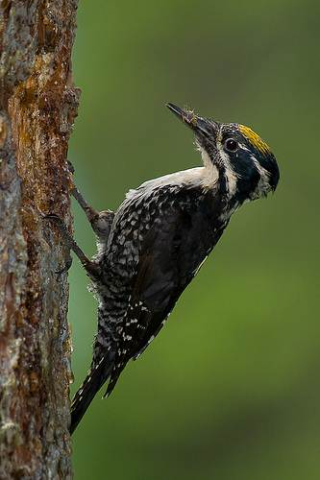

Adelie penguin (Pygoscelis adeliae)- With waterproof feathers, these birds walk on land and fly underwater with their modified wings. Their torpedo-shaped bodies help them glide through the water with little resistance, and they move quickly on snow and ice by sliding on their bellies and pushing with their feet, which are positioned in a way that helps them swim. Adelie penguins live in large colonies which helps them stay warm by huddling together during the brutally cold and dark winters. They travel and rest on sea ice when it is not breeding season, catching krill, squid, and fish in their strong beak. | 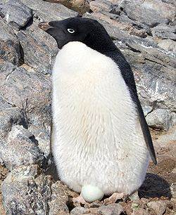
Walrus (Odobenus rosmarus)- Walruses have long tusks, which are present in both sexes. Tusks are used to form and maintain holes in the ice and aid the walrus in climbing out of water onto ice. Males use them for fighting, dominance and display in their social groups. Tusks are dragged behind through the sediment on the ocean floor while the upper edge of the snout is used for digging clams and other creatures from the seabed. Whiskers around the snout are highly sensitive, and allow the walrus to feel clams. It's mouth is shaped to maximize sucking pressure, and it sucks the clam out of the shell. The thick layer of fat, called blubber, helps to keep the walrus warm in the cold, arctic waters. The walrus has an air sac under its throat which acts like a floatation bubble and allows it to bob vertically in the water and sleep without drowning. | 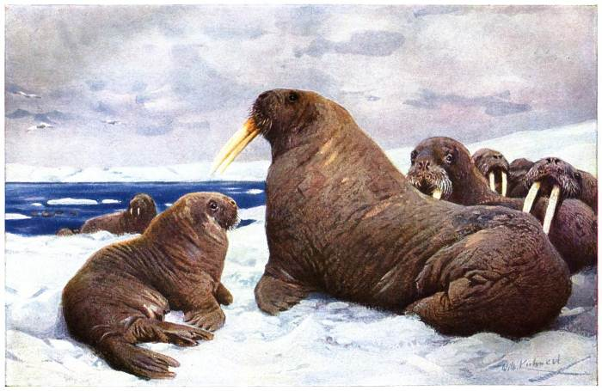

Walrus | Fisher
Scots Pine | Trehpaly Woodpecker
Scorpion | Gorilla
Panther  flying frog | Cereus cactus
Bilby | Adelie  penguin
Bromeliad

Tropical | Tropical
Subtropical/ Desert | Subtropical/ Desert
Temperate | Temperate
Polar | Polar

